C++ DSA NOTES(PART 1)
1. Skeleton of C++ Code
Har C++ program ek basic structure follow karta hai.
- #include <bits/stdc++.h>: Ye ek master header file hai. Game dev ya competitive programming mein ise use karte hain taaki baar-baar alag libraries (jaise iostream, vector, string) na likhni padein.
- using namespace std;: Taaki humein har jagah std::cout ya std::cin na likhna pade.
- int main(): Ye entry point hai. Processor sabse pehle isi ke andar ka code chalata hai.
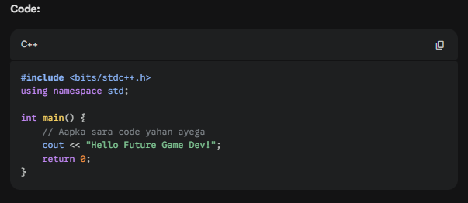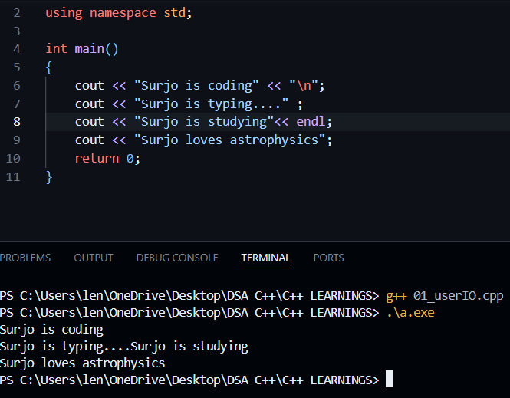

2. Input and Output (I/O)
- cout: Output print karne ke liye. Nayi line ke liye \n ya endl use hota hai (\n faster hai).
- cin: User se value lene ke liye.
- getline: Agar poora sentence (spaces ke saath) input lena hai, toh cin ki jagah getline(cin, str) use hota hai.
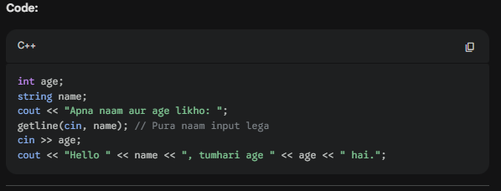
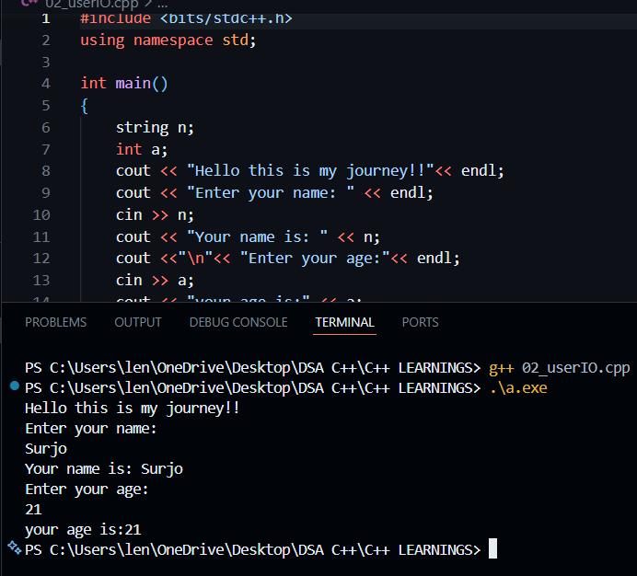

3. Data Types & Memory
Numbers aur text ko store karne ke liye alag containers hote hain:
- Integers: int (up to 10^9), long long (up to 10^{18}).
- Decimal: float, double (Game dev mein positions aur physics ke liye double best hai).
- Text: char (single character 'a'), string ("purasentence").
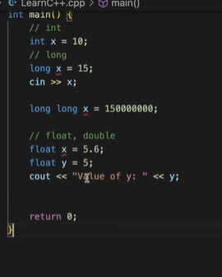
- STRING AND GETLINE
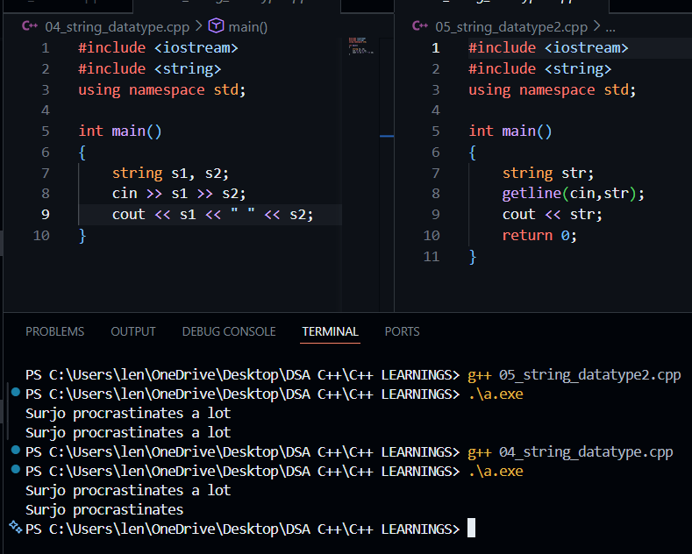
4. If-Else & Switch Statements
Decision making ke liye use hota hai. Game mein "agar player ki health 0 hai toh game over" wala logic yahi hai.
(*).Else if zaroori hai kyuki baar baar if statements likhne se code to kaam Karega lekin har statement execute hoga jisse bohot time waste hoga..and ye chiz else if se solve ho jayega!!
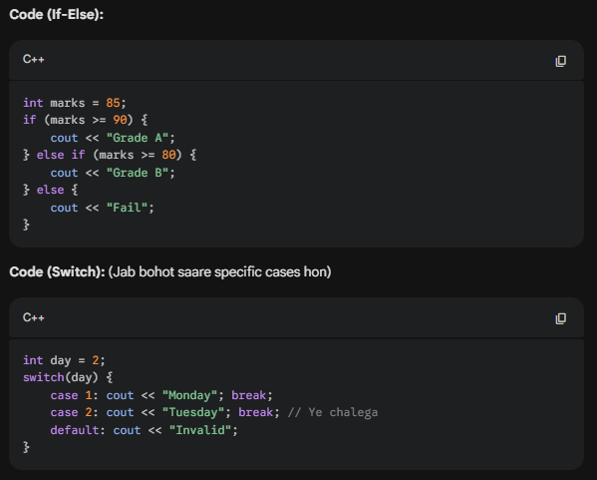

5. Arrays & 2D Arrays
Multiple values ek hi variable mein store karne ke liye. Game dev mein 2D Arrays maps ya grid banante waqt bohot kaam aate hain.
- Indexing: Hamesha 0 se start hoti hai.
- Memory: Array ki saari values memory mein ek ke baad ek (consecutive) store hoti hain.
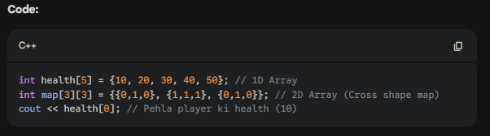
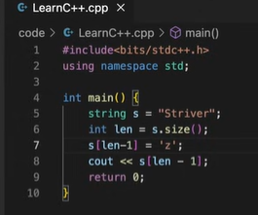 * IF YOU WANT TO ACCESS CHARACTER FROM ANY STRING..WO KIYA JAA SAKTA HAI BCOZ STRING KA BHI ARRAY KE INDEX KI TARAH HI STORE HOTA HAI CHARACTER..SO AGAR KUCH CHANGES BHI KARNA RAHE CHARACTER ME TO HAME USME “ ” KIS JAGAH ‘ ’ USE KARNA HOGA!!
6. Loops (For, While, Do-While)
Repeated tasks ke liye. Jaise ki game mein 10 dushman spawn karna.
- For Loop: Jab pata ho kitni baar chalana hai.
- While Loop: Jab tak condition true hai tab tak chalta rahega.
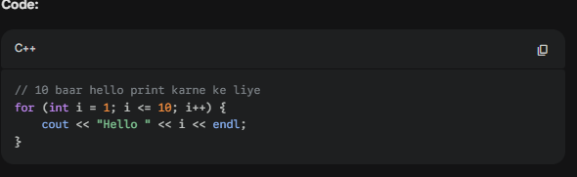
7. Functions (Modular Code)
Code ko chote chote chunks mein divide karne ke liye.
- void: Jab function kuch return nahi karta (bas kaam karta hai).
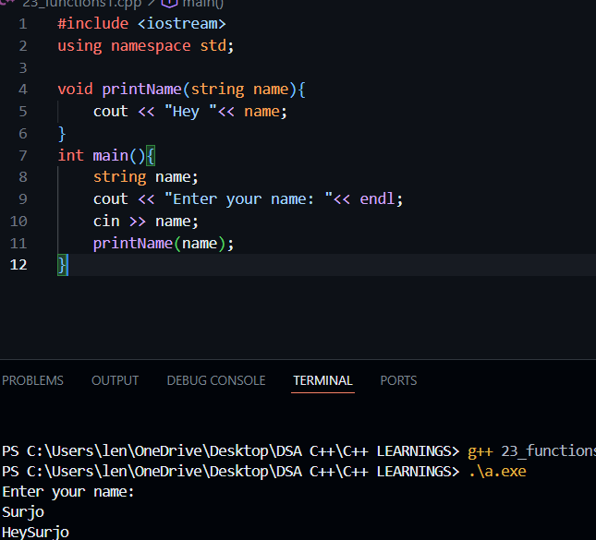
- return: Jab function calculation karke value wapas deta hai.
- Parameterised
- Non-parameterised
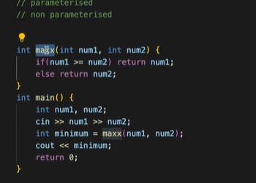 Yaha parr kuch aise functions hote hai jo inbuilt hote hai..like max() ya min()..to uss same name ka naam hame functions ke naam ko nahi dena hai!!
ALSO AGAR INT RETURN TYPE HAI TO ZAROOR USKA RETURN VALUE HOGA HI HOGA TO WO RETURN KARNA BOHOT ZAROORI HAI..!!
8. Pass by Value vs Pass by Reference (Very Important)
- Pass by Value: Function ko original variable ki copy milti hai. Agar function ke andar change kiya, toh original pe asar nahi padega.
- Pass by Reference (&): Function ko original variable ka address milta hai. Function mein change kiya toh original bhi badal jayega.
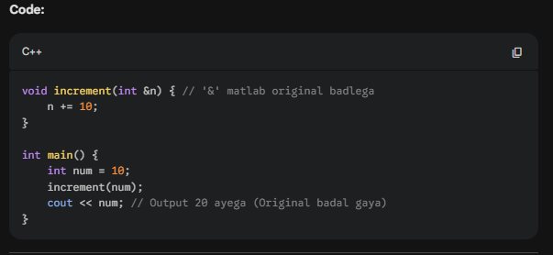
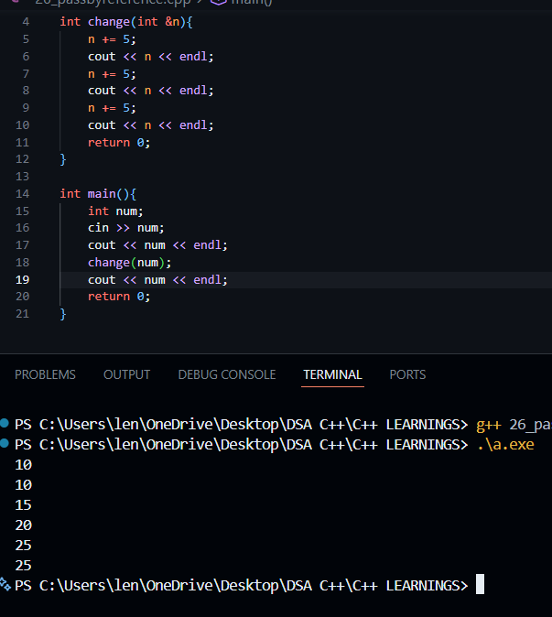
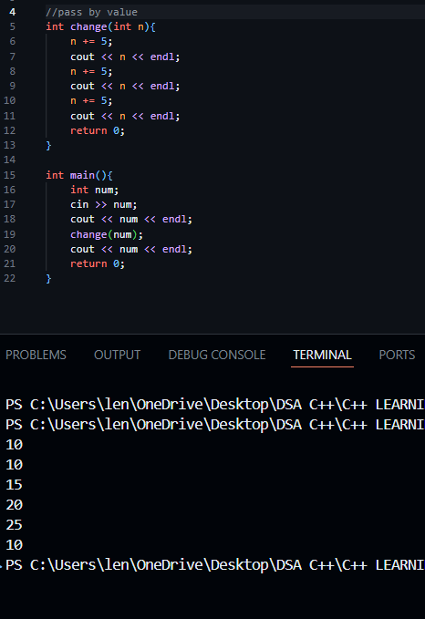

WITH STRINGS
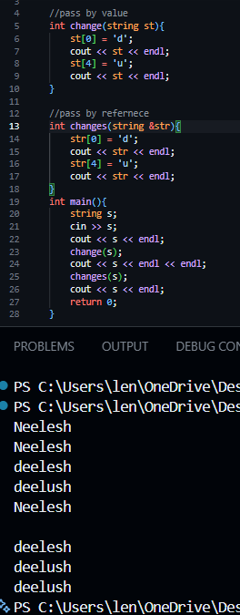

Note: Arrays hamesha reference se pass hote hain, unhe & ki zaroorat nahi hoti.
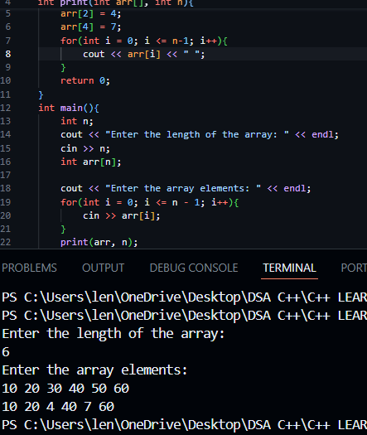
(Q). WHY return 0 is important at the last??
Ye aksar beginners ko confuse karta hai ki jab code bina return 0; ke chal raha hai, toh hum use likhte hi kyu hain.
Iska asli reason Operating System (OS) aur Program Standards se juda hai. Chalo isse simplify karke samajhte hain:
1. int main() ka matlab kya hai?
C++ mein jab tum int main() likhte ho, toh tum OS ko bata rahe ho ki "Ye function khatam hone ke baad ek Integer value wapas (return) karega."
- return 0;: Iska matlab hota hai "Success". OS ko signal milta hai ki program bina kisi error ke khatam hua.
- return 1; (ya koi non-zero value): Iska matlab hota hai "Failure" ya "Error".
2. Bina likhe kyu chal jata hai?
Modern C++ compilers (jaise GCC ya Clang) bohot smart hain. Agar tum main() function ke end mein return 0; nahi likhte, toh compiler automatically wahan ek return 0; maan leta hai. Ise hum "Implicit Return" kehte hain.
Isliye tumhara code sahi se chalta hai, kyunki compiler ne tumhari galti (ya laziness) ko sambhal liya.
3. Kab likhna zaroori hai aur kab nahi chalega?
Tumhe return likhna hi padega in cases mein:
- User-defined Functions: Agar tumne apna khud ka function banaya hai, jaise int sum(int a, int b), toh wahan compiler automatic return nahi karega. Wahan tumhe return likhna hi padega, warna error aayega.
- Old Compilers: Purane zamane ke compilers itne smart nahi hote the; wahan return 0; na likhne par error aa jata tha.
- Strict Standards: Agar tum kisi aisi company ya environment mein kaam kar rahe ho jahan strict coding standards hain, toh wahan har cheez explicitly likhni padti hai.

4. Game Dev Perspective se samjho 🎮
Game development mein tum aksar bade engines (Unreal Engine) ya libraries use karoge.
Socho tumne ek game banaya. Game ka main program khatam hone par OS ko batana zaroori hai ki:
- Game normal band hua (Player ne 'Exit' dabaya) -> Return 0
- Game crash ho gaya (Memory full ho gayi) -> Return 1
Agar tumhara program crash hota hai aur tumne koi error code return nahi kiya, toh OS ko pata hi nahi chalega ki crash hua hai, aur wo crash logs generate nahi kar payega.
5. void main() vs int main()
Pehle log void main() likhte the kyunki void kuch return nahi karta. Lekin C++ standard rules ke mutabik main ko hamesha int hi hona chahiye. Isliye hamesha int main() use karo.

C++ DSA NOTES(PART 2)
1. Time Complexity ka Asli Matlab
Sabse bada confusion ye hota hai ki Time Complexity matlab "kitne seconds lage". Lekin ye galat hai.
- Problem with Time (Seconds): Agar tum ek hi code do alag computers (ek purana PC aur ek naya Gaming Laptop) par chalaoge, toh naya laptop use jaldi khatam kar dega. Iska matlab ye nahi ki code badal gaya.
- Asli Definition: Time Complexity ka matlab hai "Rate of increase of time with respect to input size."
  - Matlab, agar main input ka size (n) badhaun, toh program ke operations kis speed se badhenge.
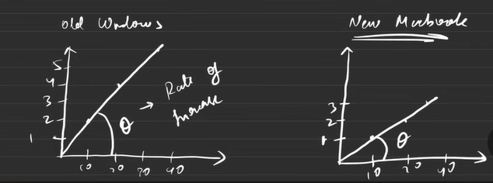

2. Big O Notation ({O})
Interviews aur Competitive Programming mein hum time ko Big O notation mein batate hain. Ye basically program ka "Upper Bound" (sabse bura case) hota hai.
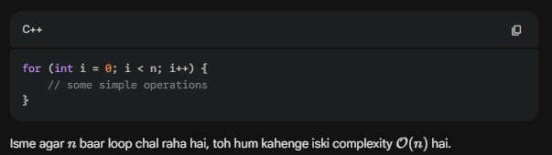

3. Time Complexity Compute Karne ke 3 Rules
Striver ne 3 main rules bataye hain jo har student ko pata hone chahiye:
- Rule 1: Always Compute for the Worst Case
Duniya mein teen scenarios hote hain:
  - Best Case: Sabse kam mehnat (luck accha hai).
  - Average Case: Beech ka rasta.
  - Worst Case: Sabse zyada operations (Luck kharab hai).
Interviewer hamesha Worst Case hi poochta hai kyunki humein system ki maximum limit check karni hoti hai.
- Rule 2: Avoid Constants
Agar aapka result {O}(2n + 5) aata hai, toh hum '2' aur '5' ko ignore kar dete hain. Final answer hoga {O}(n).
Logic: Jab n ki value bohot badi (10^{18}) ho jati hai, toh chote constants ka koi significance nahi rehta.
- Rule 3: Avoid Lower Values
Agar complexity n^2 + 5n + 10 hai, toh hum sirf sabse bade factor ko rakhte hain. Answer: {O}(n^2).
Logic: n^2 ke saamne 5n ki koi value nahi hai jab n bohot bada ho.

4. Case Study: Grade System (Best vs Worst Case)
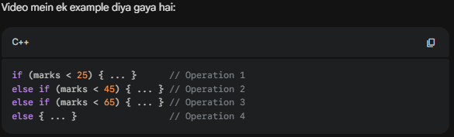
- Best Case: Agar marks 10 hain, toh sirf pehla if check hoga. Program wahi ruk jayega. Complexity: {O}(1).
- Worst Case: Agar marks 80 hain, toh program ko saare if-else check karne padenge aur end mein else tak jana padega. Complexity: {O}(4), jise hum constant {O}(1) hi kahenge.
5. Other Notations (Sirf Knowledge ke liye)
- Big O ({O}): Upper Bound (Worst Case). Sabse zyada yahi use hota hai.
- Theta (Theta): Average Case.
- Omega (Omega): Lower Bound (Best Case).

Game Dev Perspective:
Game Dev mein humein "O(1)" ya "O(log n)" ki bohot chahat hoti hai. Socho agar tumhare game mein 10,000 dushman (NPCs) hain aur har dushman ke liye tum ek {O}(n^2) ka loop chala rahe ho, toh frame rate (FPS) gir jayega aur game "Lag" karne lagega. Isliye hamesha "Optimized Code" likhna padta hai.

1. Nested Loops ki Complexity Kaise Nikalein?
Jab ek loop ke andar dusra loop hota hai, toh operations multiply ho jate hain. Iske do main patterns Striver ne samjhaye hain:
Pattern A: Independent Nested Loops
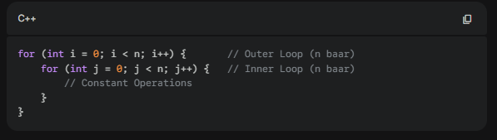
- Logic: Har ek i ki value ke liye, j wala loop poora n baar chalta hai.
- Calculation: n \times n = n^2.
- Complexity: {O}(n^2).
Pattern B: Dependent Nested Loops (Triangle Pattern)
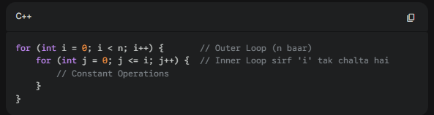
- Logic: * Jab i=0, loop 1 baar chala.
  - Jab i=1, loop 2 baar chala.
  - Jab i=n-1, loop n baar chala.
- Calculation: Ye ek series ban gayi: 1 + 2 + 3 + ... + n = {n(n+1)}{2}.
- Simplification: Rule ke mutabik constants ({1}{2}) aur lower values (n) hata do.
- Complexity: {O}(n^2). (Bhale hi ye poora n^2 nahi hai, lekin growth rate n^2 hi mana jata hai).
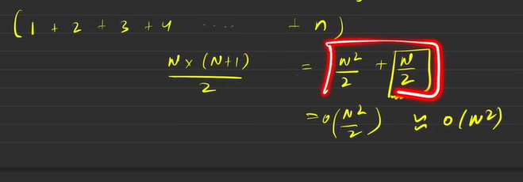
2. Space Complexity
Sirf time hi nahi, program kitni memory (RAM) use kar raha hai, wo bhi zaroori hai.
Definition: Program ko chalane ke liye jo extra memory lagti hai, use Space Complexity kehte hain.
- Formula: Space Complexity = Auxiliary Space + Input Space.
  - Input Space: Jo data user se mil raha hai (e.g., input array).
  - Auxiliary Space: Jo extra variables ya data structures tumne problem solve karne ke liye banaye.
Important Interview Rule: Kabhi bhi Input Data ko manipulate (change) mat karo jab tak bola na jaye. Agar tum input array mein hi changes karke space bacha rahe ho, toh interviewer ise galat maan sakta hai kyunki real software dev mein woh data kahin aur bhi kaam aa sakta hai. Hamesha extra variable lekar kaam karo, bhale hi thodi space zyada lage.
Example:
- int a, b, c; -> {O}(1) (Constant space kyunki sirf 3 variables hain).
- int arr[n]; -> {O}(n) (Space input size pe depend kar rahi hai).

3. 10^8 Operations Rule (The Server Secret)
Competitive programming aur online judges (LeadCode, CodeStudio) mein ye rule bohot kaam aata hai:
- Standard Rule: Aksar servers 1 second mein lagbhag 10^8 operations kar paate hain.
- Agar kisi question ka time limit 1 second hai, aur tumhara n = 10^5 hai:
  - {O}(n) solution -> 10^5 ops (Chal jayega ✅)
  - {O}(n^2) solution -> (10^5)^2 = 10^{10} ops (Time Limit Exceeded - TLE aa jayega ❌)

Game Dev Connection (Optimization) 🎮
Game development mein tumhare paas hardware ki limit hoti hai (Mobile ya Console).
- Time Complexity: Agar tumhara physics engine {O}(n^2) hai, toh 1000 objects screen par aate hi game lag karne lagega.
- Space Complexity: Agar tum har frame mein naye objects allocate kar rahe ho bina purane delete kiye, toh "Memory Leak" ho jayega aur game crash ho jayega.

Summary of Common Complexities (Increasing Order):
- {O}(1) (Constant) - Sabse tez.
- {O}(\log n) (Logarithmic) - Bohot tez (Binary Search).
- {O}(n) (Linear) - Accha hai.
- {O}(n \log n) - Sorting algorithms.
- {O}(n^2) (Quadratic) - Thoda slow (Nested loops).
- {O}(2^n) (Exponential) - Bohot slow (Recursive solutions).

C++ DSA NOTES(PART 3)
4-Step Pattern Trick
- Outer Loop: Hamesha Rows (Lines) ke liye hota hai. Count karo kitni lines hain.
- Inner Loop: Columns ke liye hota hai. Dekho har row mein kya print ho raha hai aur use row number (i) se connect karo.
- Print: Jo cheez print karni hai (Star, Number, ya Alphabet) use inner loop ke andar likho.
- Symmetry (Optional): Kuch patterns mein symmetry dekhni padti hai (adhura solve karke flip kar dena).
- SQUARE PATTERN
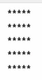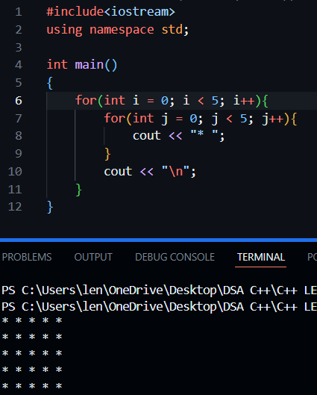

- RIGHT TRIANGLE PATTERN
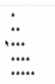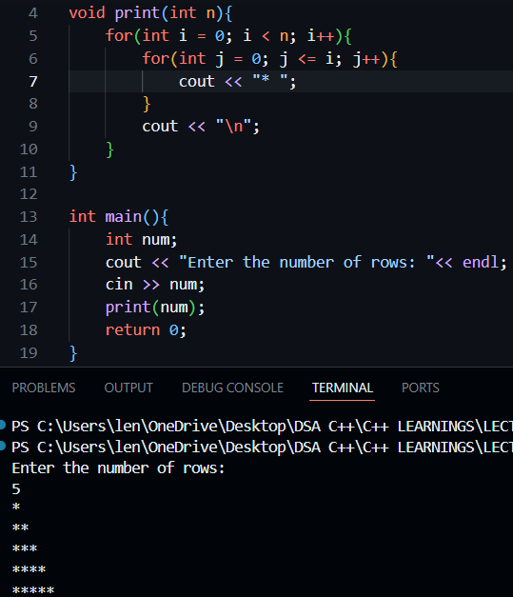

- RIGHT TRIANGLE NUMBER PATTERN(1)
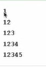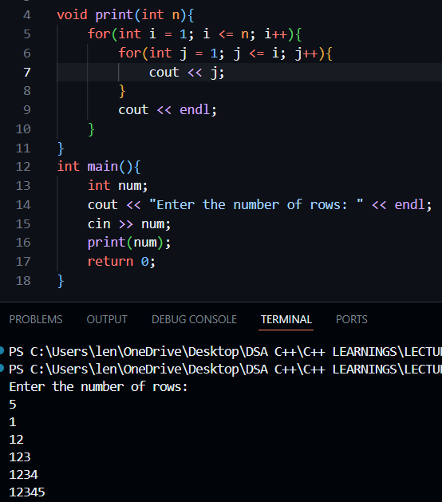

- RIGHT TRIANGLE NUMBER PATTERN(2)
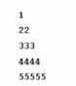
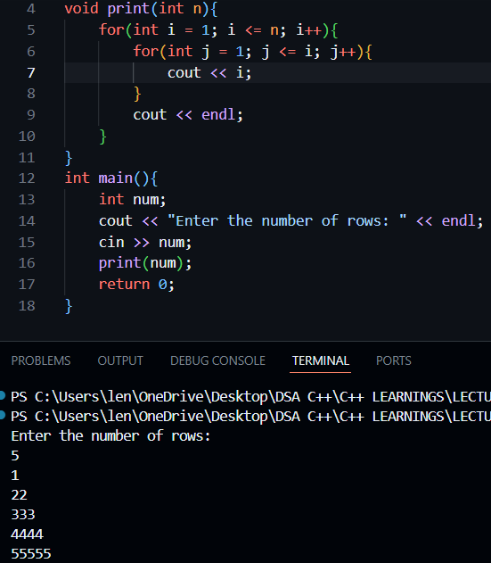

- DOWNWARD RIGHT TRIANGLE PATTERN
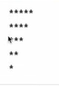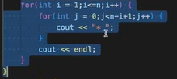
OR
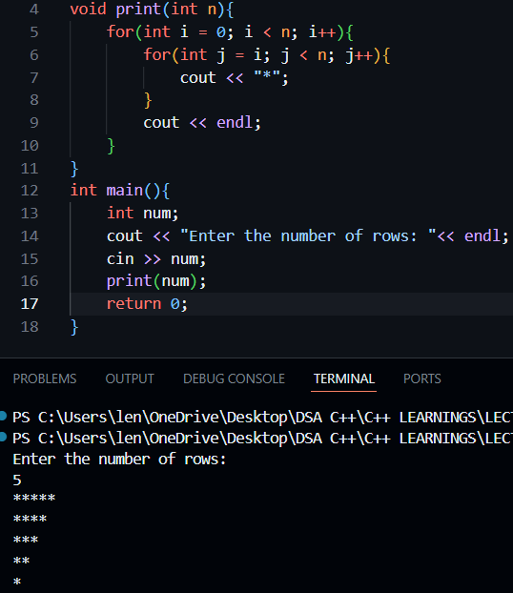

- DOWNWARD RIGHT TRIANGLE NUMBER PATTERN**(V IMP)
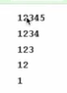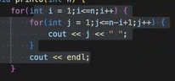
OR
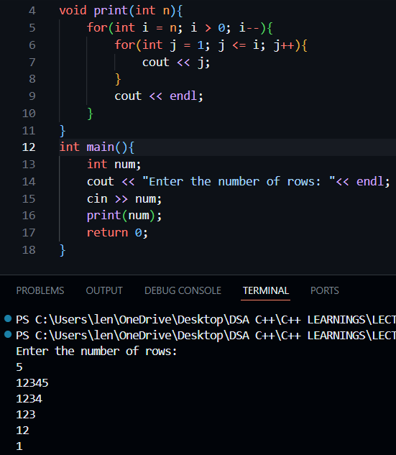

- PYRAMID PATTERN


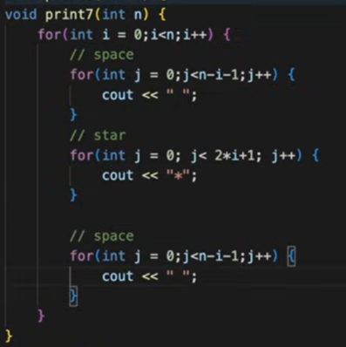

OR
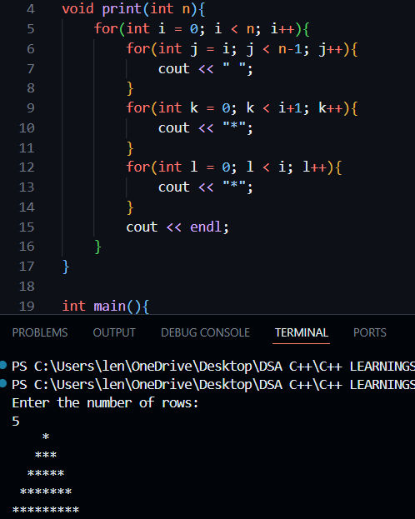

SEE IF YOU REALLY WANT TO TEEL THE DIFFERENCE BETWEEN THE TWO CODES THERE IS NOT MUCH..JUST TRY TO THINK OF SPACES AND STARS..!!
THE CODE FOR THE STARS WHICH I HAVE WRITTEN IS EXPANDED THAT’S IT!!..
SO IF U WANT TO CALCULATE THE TOTAL CONSTRAIN FOR THE STARS, JUST ADD THE TWO VALUES IN FOR LOOPS I DID FOR STARS!!

- DOWNWARD PYRAMID
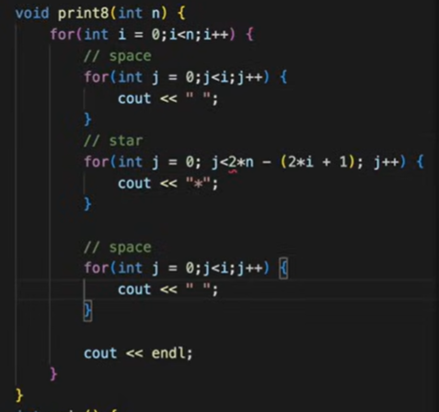

OR
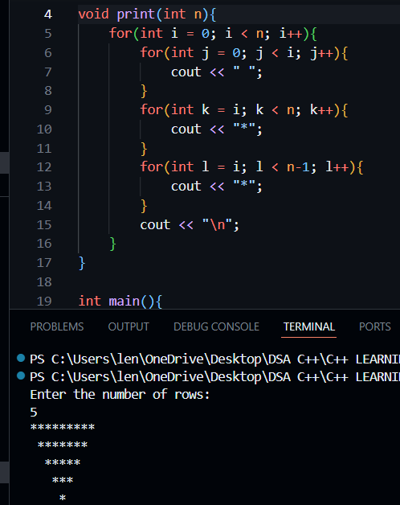

- DIAMOND PATTERN
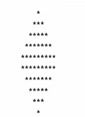

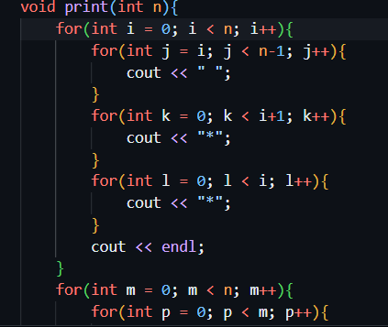
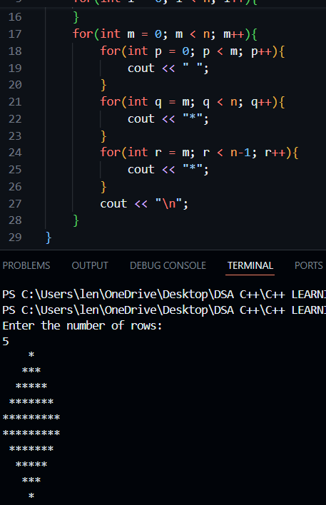

- REAL DIAMOND PATTERN*(V IMP)
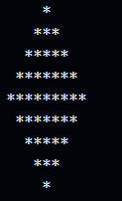

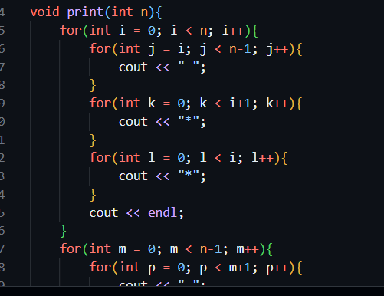
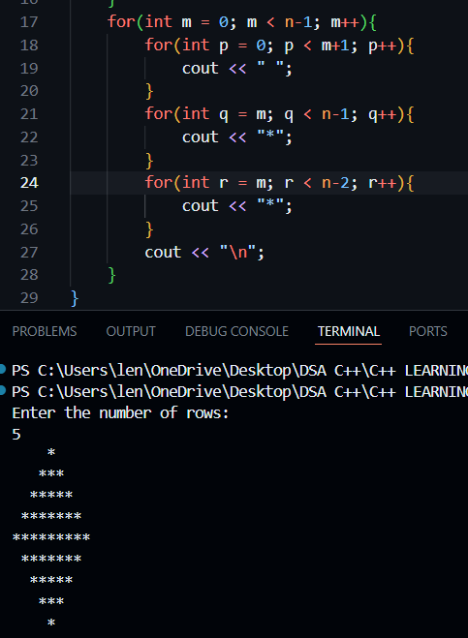

- HALF DIAMOND PATTERN
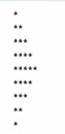

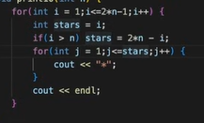
OR
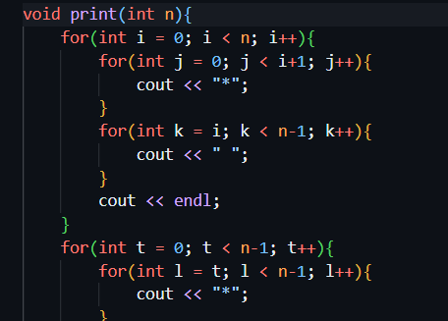
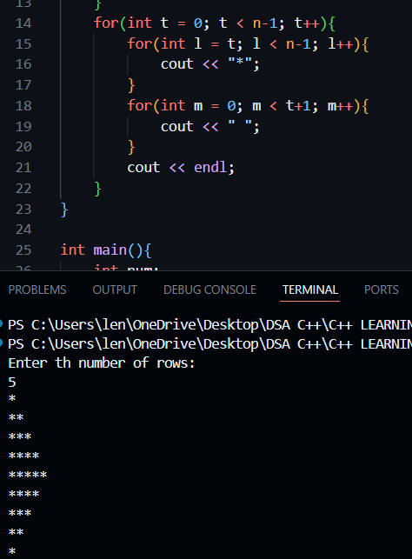

- RIGHT TRIANGLE BINARY PATTERN**(V.V IMP)
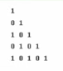

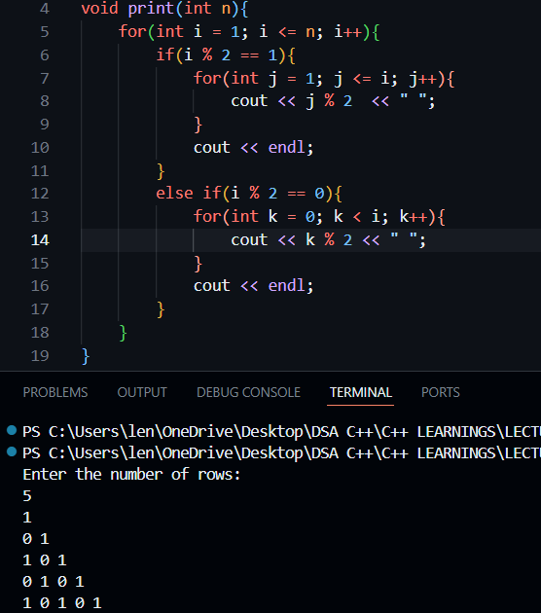

- NUMBER HILL PATTERN

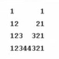
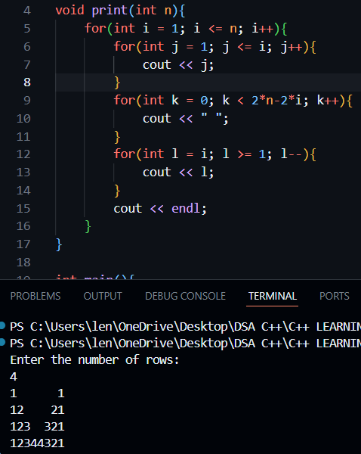

- INCREASING NUMBER RIGHT TRIANGLE PATTERN
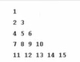

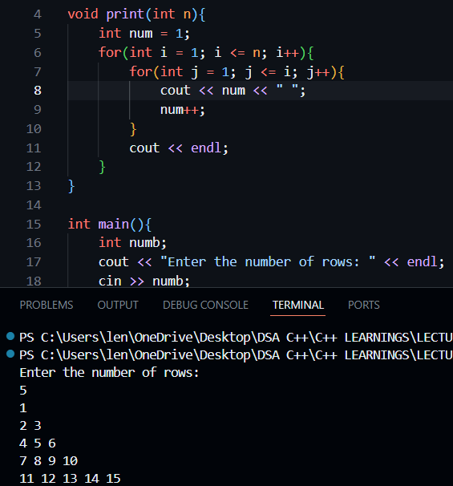

- RIGHT TRIANGLE ALPHABET PATTERN(1)

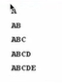
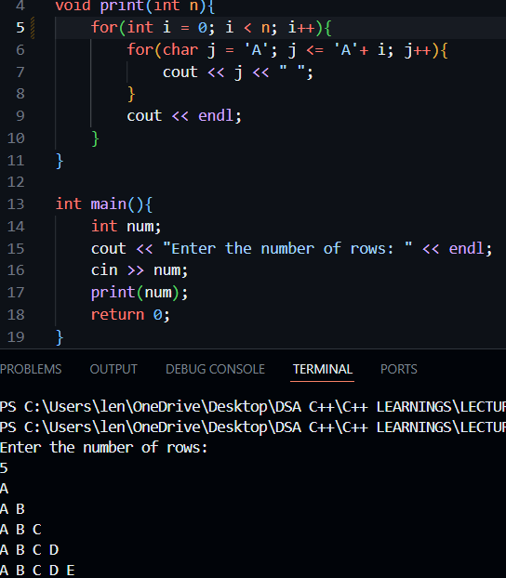
- INVERTED RIGHT TRIANGLE ALPHABET PATTERN
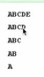
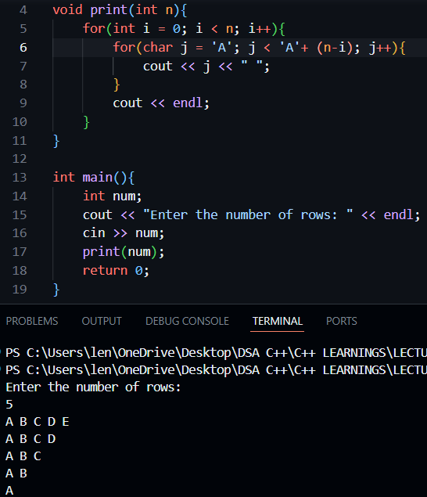

- RIGHT TRIANGLE ALPHABET PATTERN(2)
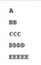
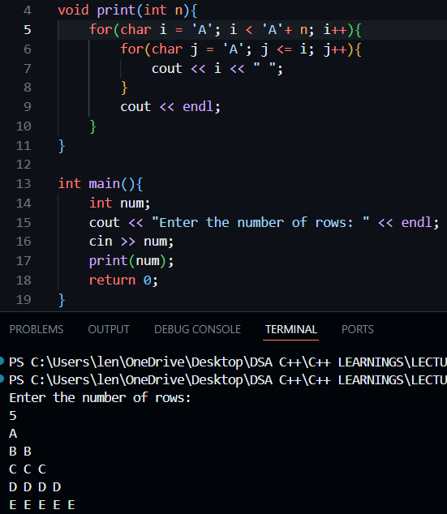

- ALPHABET PYRAMID PATTERN**(V.V IMP)
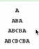
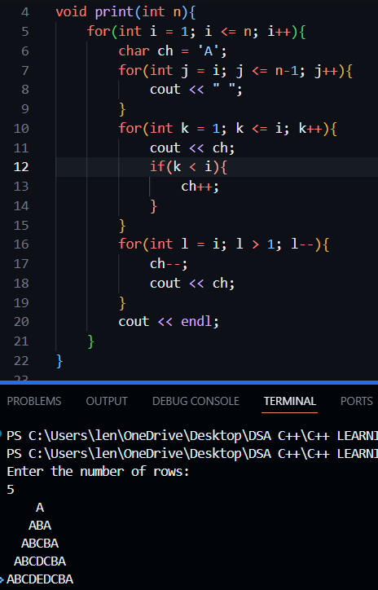
- INVERTED DECREASING RIGHT TRIANGLE ALPHABET PATTERN
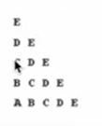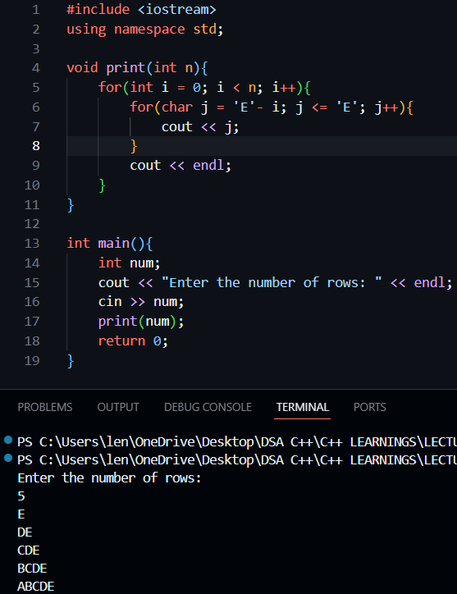

- EMPTY RHOMBUS STAR PATTERN
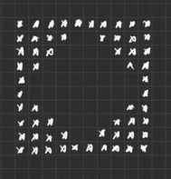
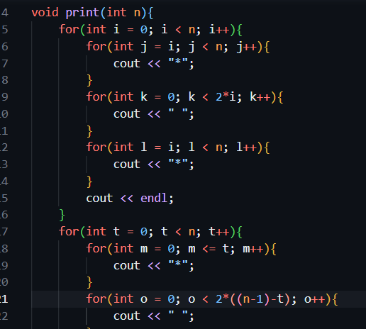
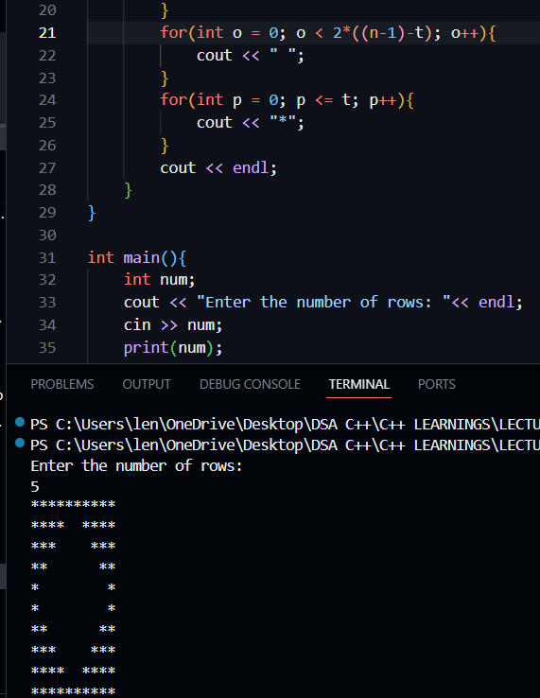

- BUTTERFLY PATTERN
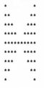
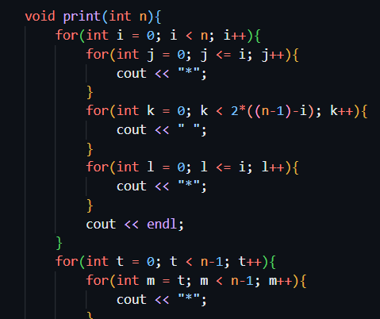
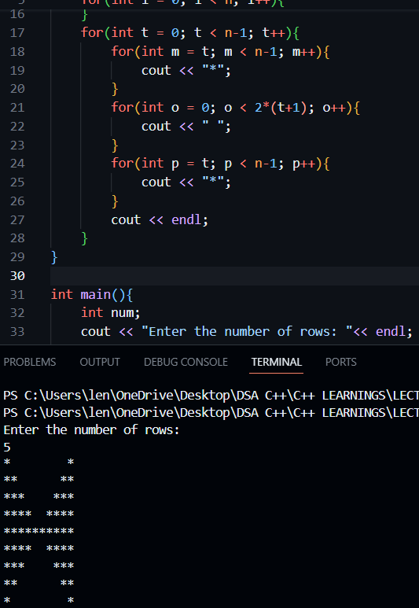

- EMPTY RECTANGLE PATTERN

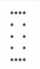
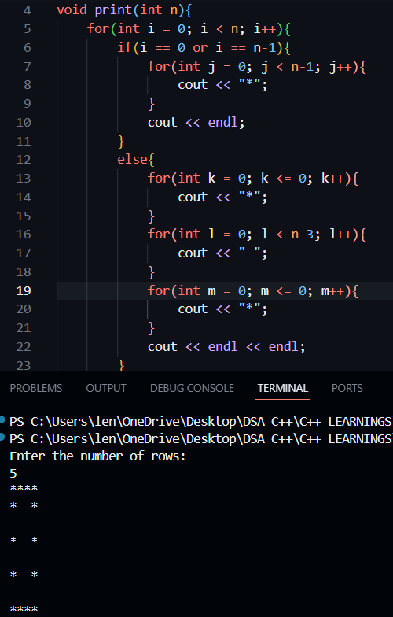

- ENCLOSING NUMBER SQUARE PATTERN

